This is how I have imagined the class: an 8 minute summary from me. Then, Arkady speaks on Lacan and mathematics for 20+ minutes? Then I mention the main questions that occur to me but without discussion move on to the production and usefulness of “parole;” about 15 minutes. And then I ask the questions I had mentioned and Arkady comments on whatever I say and we have a short exchange for the benefit of the students. Then, Michael and the students ask questions, until Michael moves into his own presentation in the last half hour.
Summary
I had a good conversation with Cy during office hours and therefore should say that there is nothing wrong with summarizing. It’s just not the thing I am looking for in your responses. Here now is a summary:
1. The Drives (German Triebe). Generally translated impulse or instinct, but now people have started using the word “drive.” These are not located in a subject. The drive first establishes borders. This is not available to the subject, because the subject is not yet put together. (Let us call this “metapsychological.”) Therefore no image can be found of it (To look forward, perhaps this is why Lacan needs “geometrically un-epistemologizable” [Plotnitsky] representations for it?). Lacan writes:
A common characteristic of these objects as I formulate them is that they have no specular image, in other words, no alterity. This is what allows them to be… the lining…of the very subject people take to be the subject of consciousness… the lips, "the enclosure of the teeth," the rim of the anus, the penile groove, the vagina, and the slit formed by the eyelids, not to mention the hollow of the ear (I am avoiding going into embryological detail here). (692-3)
Un trait commun à ces objets dans notre élaboration : ils n'ont pas d'image spéculaire, autrement dit d'altérité. C'est ce qui leur permet d'être…la doublure…du sujet même qu'on prend pour le sujet de la conscience…lèvres , « enclos des dents >>, marge de l'anus, sillon pénien, vagin, fcnte palpébrale, voire cornet de l'oreille (nous évitons ici les précisions embryologiques). (817-8)
This is where Freud leads Lacan to a solution of one of the chief philosophical problems: the body/mind problem. This is why Lacan says Hegel is the metonym of psychoanalysis. “Metonym” because, Lacan turns it around by using error. Listen to this Hegel: “…if the suppression of the body requires an instrumental movement of and by the body, then the body is in advertently preserved [aufgehoben] in and by the instrument of its suppression” and look at the productive role of “fantasy”’s programmed “error” from the body-mind barrier turned into margin.
2. Once the borders are established by the drives, fantasy is programmed to make a mistake and make this “speculable,” – mirrorable – so that the subject can be formed out of this programmed error. By creating an image, fantasy creates a subject-object situation and thus something that may be called Desire, something inclining toward something, without being located in a subject: a sense – sens, Sinn (you can see that Freud was a student of Brentano, who was Husserl’s teacher; and Lacan attended Koyré’s lectures, and Koyré was a student of Husserl and Hilbert).
3. To represent this speculability, Lacan has his famous mirror phase, (first version 1936) where the child looks at his image and thinks of himself as whole. This is the “Imaginary,” the subject not yet fully formed. In older Freudian language, narcissism (as it happens, “secondary,” but I can’t go there in a summary).
4. The Desire produced by fantasy, represented in the mirror stage, continues on to help in the formation of the subject by constituting objects to be desired that are still algebraic and have no reality. One of them clicks the signifier machine which is the unconscious (my own image is of the unconscious like a moving bicycle chain, which suddenly catches). To put this accessible metaphor formally, this is a different use of the relentlessness (Wittgenstein) of logic – it is the logic of individual contingency in a corporeal interiority.
A signifier is produced. The mechanical details of this have no place in a summary, but let me just say that it produces a proposition, grammatically correct, but factually not necessarily so. Its correctness or incorrectness is immaterial. Lacan’s example: “The dog goes meow, and the cat goes bow-wow.” We are entering the area of the “Symbolic,” through which the analyst can catch at the patient’s “Imaginary.” And that sentence is “the Real.”
The unconscious is a signifier machine, turning round and round until something catches.
5. As to how the “Symbolic” works through the Law of the Father is not our business here. My section of the readings will be about how the “parole” (inadequately translated as “speech”) emerges to help the “Symbolic” produce the “Imaginary.”
- I have already told you that Freud and Lacan found in literature a staging of the impossible. This is why: “This is why I have decided to illustrate for you today the truth which brings itself forth from the moment of Freud's thought we have been studying—namely, that it is the symbolic order which is constitutive for the subject—by way of demonstrating to you in a story the major determination the subject receives from the itinerary of a signifier [“the letter”].” (E 7; Tr modified)
- Lacan comments on the agency of the letter in the unconscious. “Letter” here carries a pun, but you can slip this into the image of the bicycle chain that I have offered you and think that in the story the letter represents a letter in an alphabet. Under its influence, I published 43 years ago a piece in Yale French Studies called “The Letter as Cutting Edge,” which I have shared with Cy since he wanted help with Lacan. If interested, check it out. In a summary, I will say that Lacan offers the proposition that “the letter always arrives at its destination.” Although Derrida proposed the magnificent idea of “destinerrance” – that “the letter never arrives at its destination” – I think my reader’s task has been not to see this as a binary opposition.
- He does not think poets are better than mathematicians:
All fools are poets; this the Prefect feels; and he is merely guilty of a non distributio medii in thence inferring that all poets are fools."
"But is this really the poet?" I asked. "There are two brothers, I know; and both have attained reputation in letters. The Minister I believe has written learnedly on the Differential Calculus. He is a mathematician, and no poet."
"You are mistaken; I know him well; he is both. As poet and mathematician, he would reason well; as mere mathematician, he could not have reasoned at all, and thus would have been at the mercy of the Prefect."
"You surprise me," I said, "by these opinions, which have been contradicted by the voice of the world. You do not mean to set at naught the well-digested idea of centuries. The mathematical reason has long been regarded as the reason par excellence.
"'Il y a a parier,'" replied Dupin, quoting from Chamfort, "'que toute idee publique, toute convention recue, est une sottise, car elle a convenu au plus grand nombre.' The mathematicians, I grant you, have done their best to promulgate the popular error to which you allude, and which is none the less an error for its promulgation as truth. With an art worthy a better cause, for example, they have insinuated the term 'analysis' into application to algebra. The French are the originators of this particular deception; but if a term is of any importance --if words derive any value from applicability --then 'analysis' conveys 'algebra' about as much as, in Latin, 'ambitus' implies 'ambition,' 'religio' religion or 'homines honesti,' a set of honorable men."

This gives way to making fun of the Prefect's error when he deduces that because the Minister is a poet, he is only one remove from a fool, an error, it is argued, that simply consists, although this is hardly negligible, in a non distributio medii, since it is far from following from the fact that all fools are poets. Yes indeed. But we ourselves are left to err regarding what constitutes the poet's superiority in the art of concealment—even if he turns out to be a mathematician to boot—since we suddenly lose whatever momentum we had when we are dragged into a thicket of unprovoked arguments directed against the reasoning of mathematicians, who have never, to my knowledge, showed such devotion to their formulas as to identify them with reasoning reason. At least, let me bear witness to the fact that, unlike what seems to be Poe 's experience, 23 I occasionally hazard such serious mischief (virtual blasphemy, according to Poe) before my friend Riguet—whose presence here guarantees you that my incursions into combinatorial analysis do not lead us astray—as to question whether perhaps "x2 +px is not altogether equal to ^," without ever (here I refute Poe) having to fend off any unexpected attack. (Lacan, 15)
This is the moment to turn things over to Arkady to talk to us about Lacan and mathematics.
Parole
In 1953, Lacan established his own organization and presented the celebrated “The Function and Field of Speech [“parole”] and Language in Psychoanalysis.”
34. This for the use of whoever can still understand it after looking in the Littre for justification of a theory that makes speech into an "action beside," by the translation that it gives of the Greek parabole (why not "action toward" instead?)—without having noticed at the same time that, if this word nevertheless designates what it means, it is because of sermonizing usage that, since the tenth century, has reserved "Word" [verbe] for the Logos incarnate. (267)
1.. Ceci à l'usage de qui peut l'entendre encore, après avoir été chercher dans le Littré la justification d'une théorie qui fait de la parole une « action à côté >>, par la traduction qu'il donne en effet du grec parabolê (mais pourquoi pas « action vers >> ?) sans y avoir du même coup remarqué que si ce mot toutefois désigne ce qu'il veut dire, c'est en raison de l'usage sermonnaire qui réserve le mot verbe, depuis le x^{e} siècle au Logos incarné. (298)
Consulting the Greek English Lexicon, we could say that, if logic takes us from a to b, the parable (parole) communicates with us like a boomerang. Simplified, it’s the Freudian joke: why did you tell me you were going to Limberg when you’re really going to Limberg, so that I would think you were going to Krakow? And Lacan: “truth draws its guarantee…from the Parole. From it, it receives that mark which institutes in a structure of fiction.” (trans modified) “The Purloined Letter” boomerangs us.

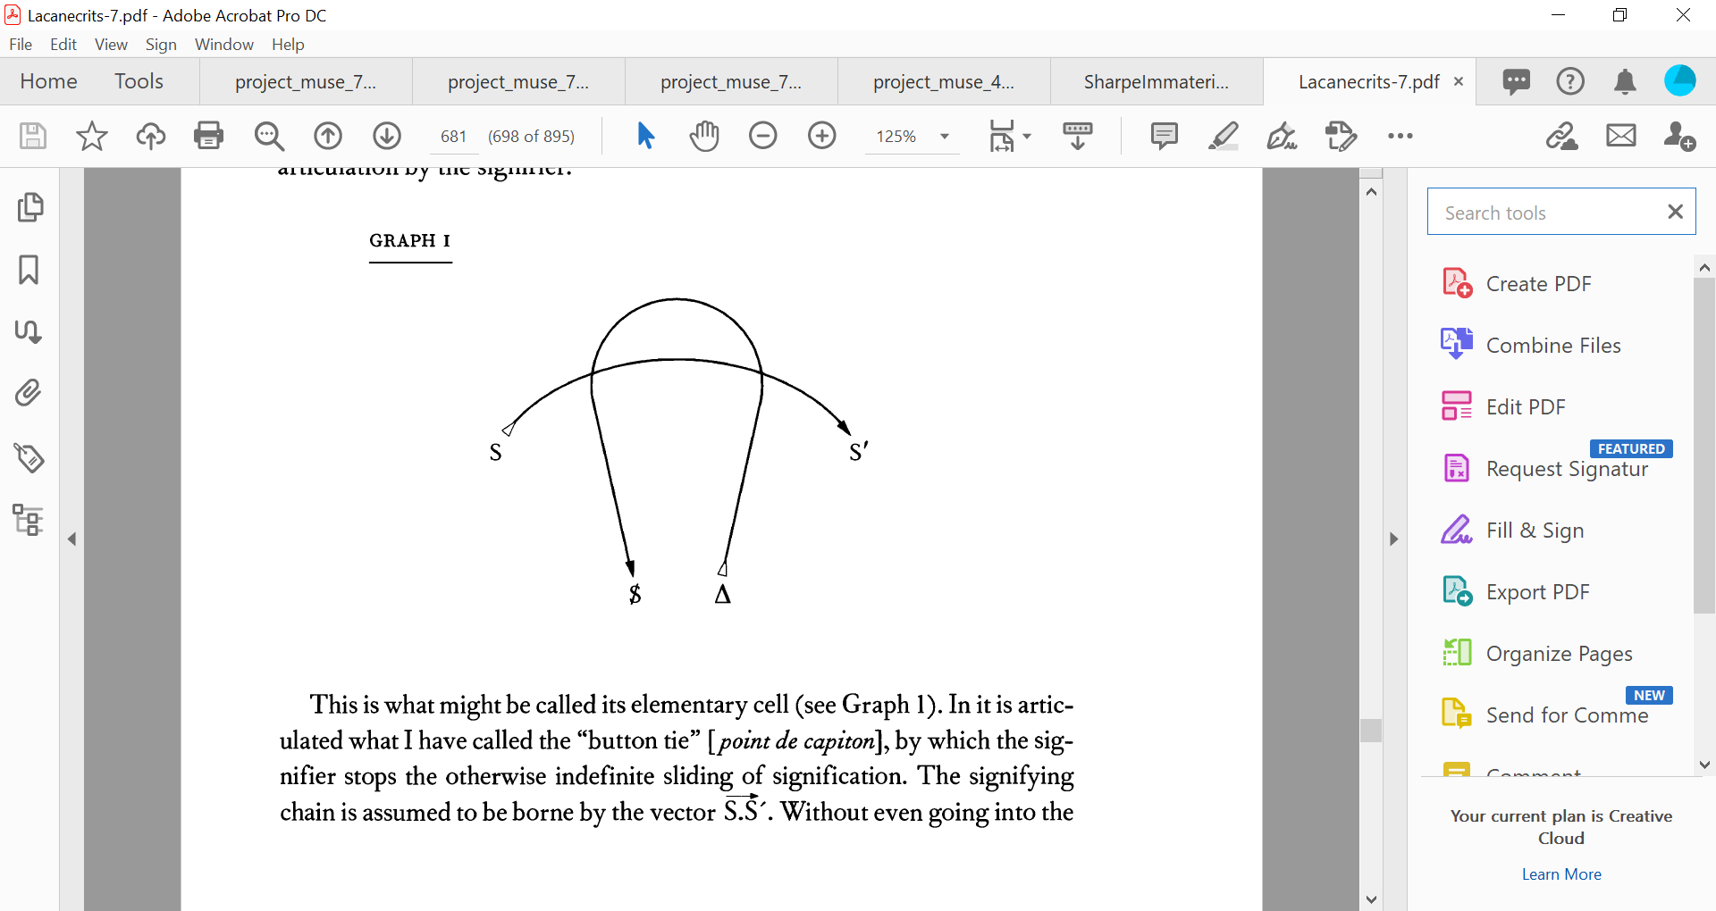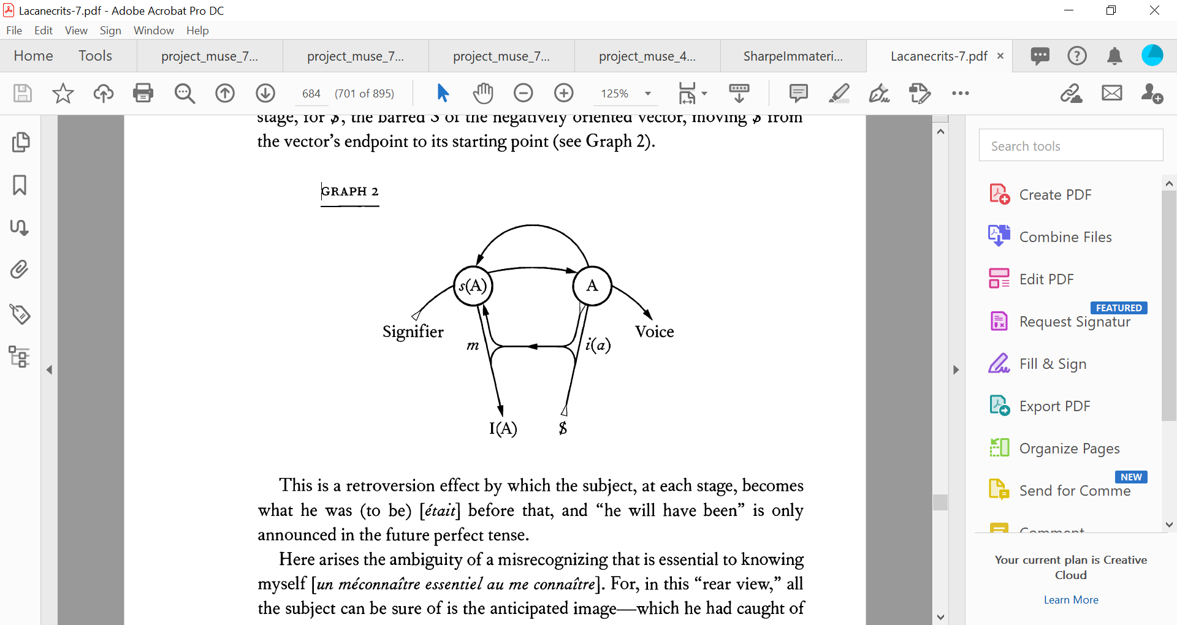

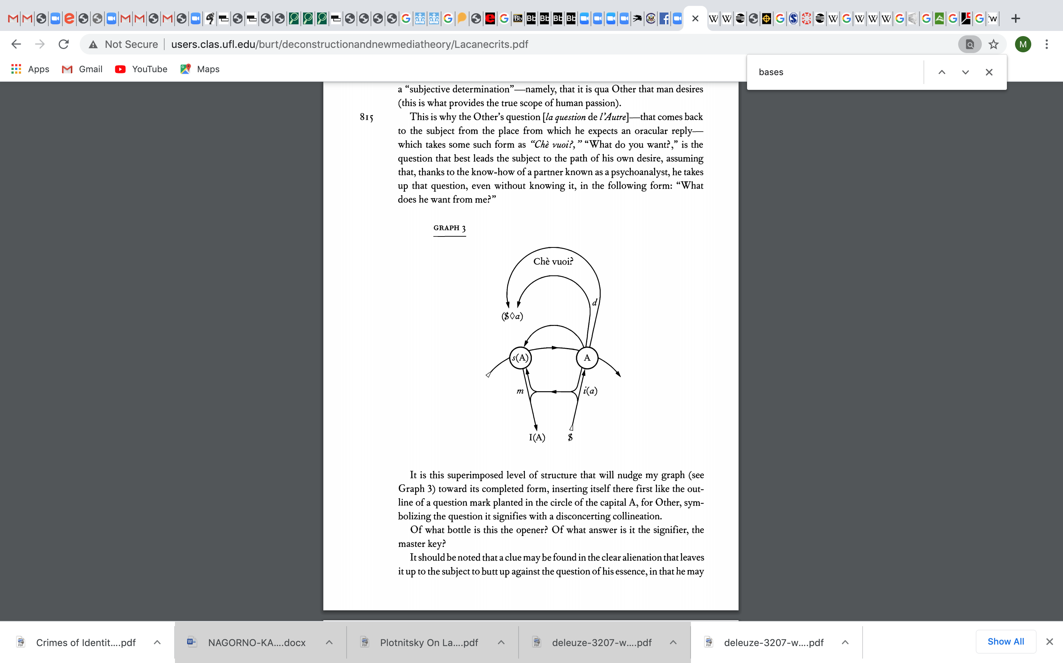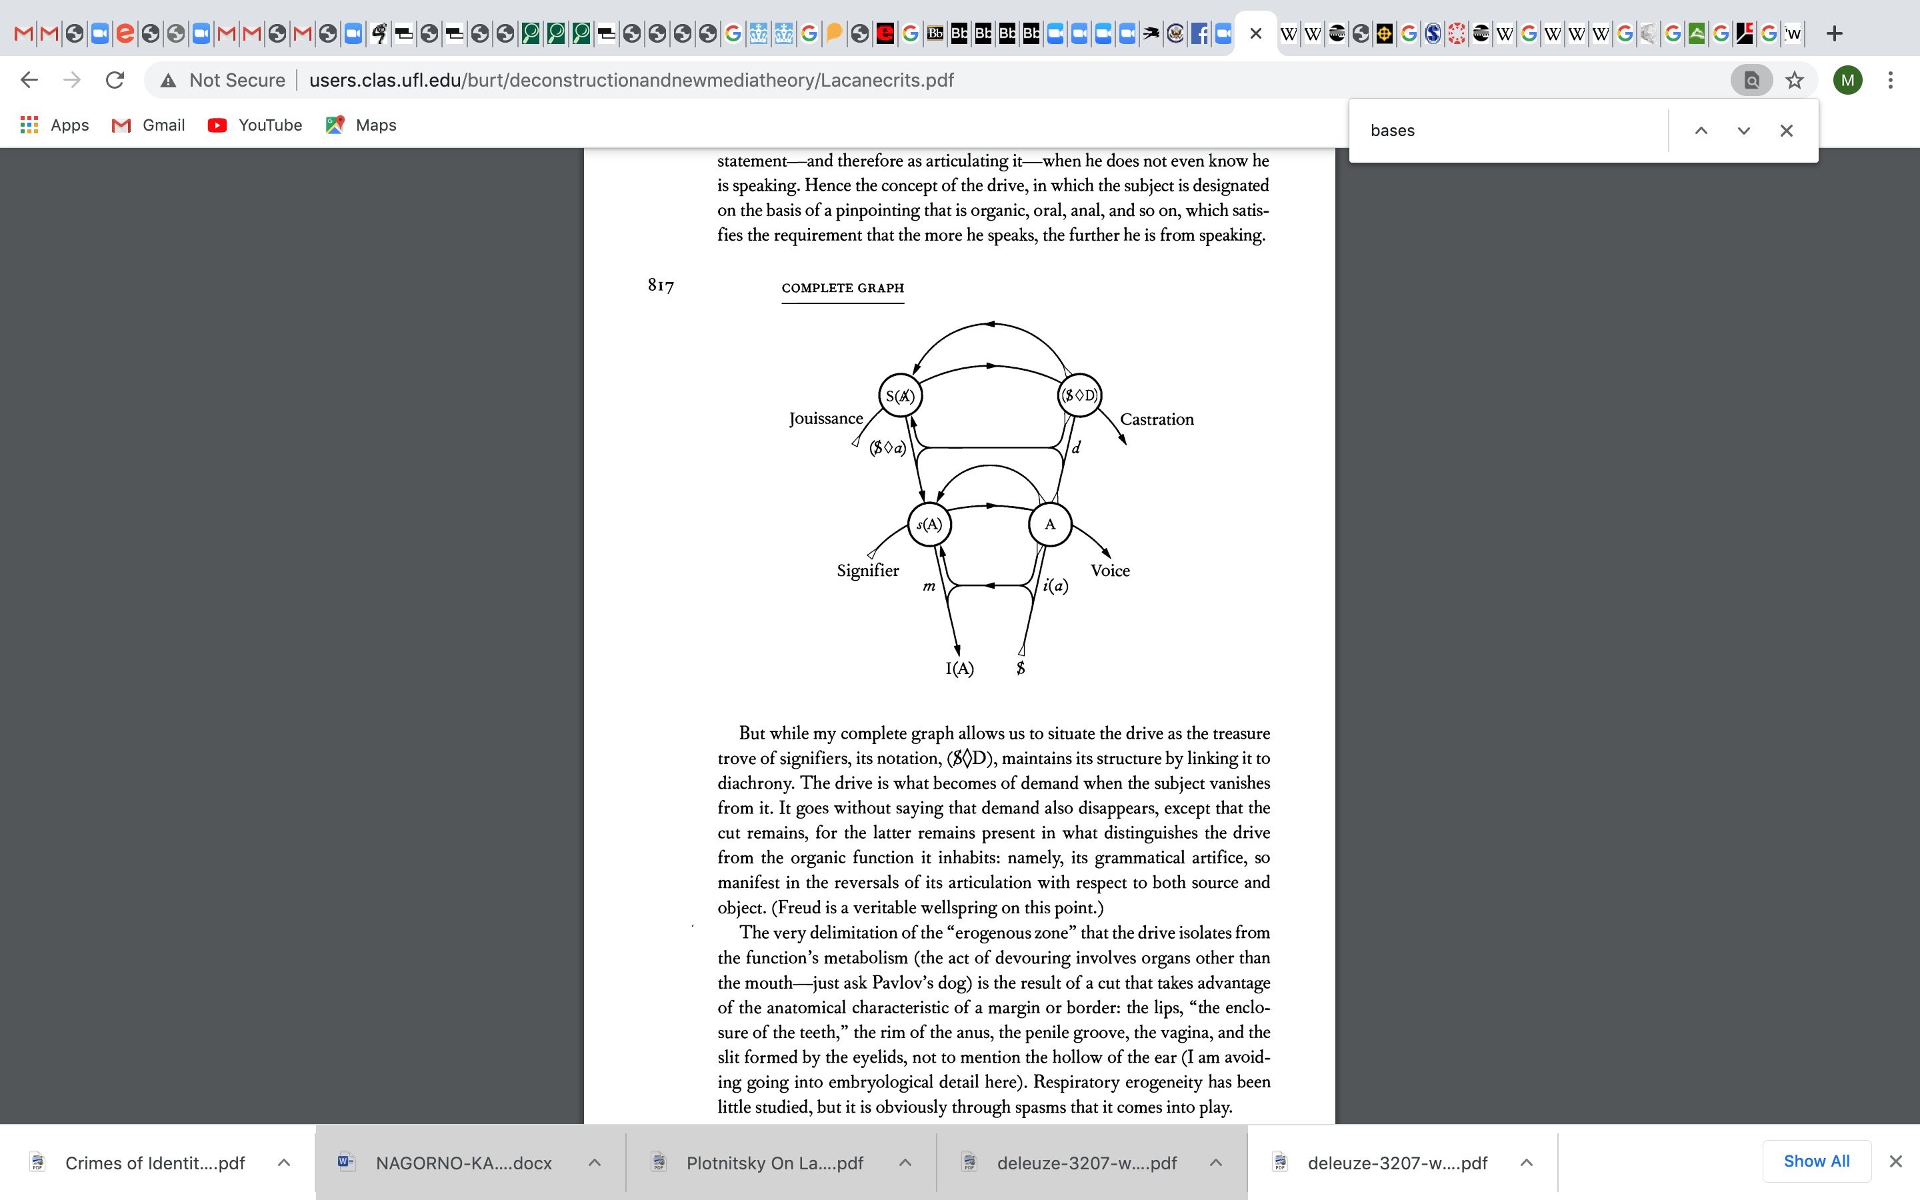
The primary character of symbols in fact makes them similar to those numbers out of which all other numbers are composed; and if they therefore underlie all the semantemes of a language, we shall be able to restore to speech its full evocative value by a discreet search for their interferences, following the course of a metaphor whose symbolic displacement neutralizes the secondary meanings of the terms it associates.
To be taught and to be learned, this technique would require a profound assimilation of the resources of a language \langue\ especially those that are concretely realized in its poetic texts. It is well known that Freud was steeped in German literature, which, by virtue of an incomparable translation, can be said to include Shakespeare's plays. Every one of his works bears witness to this, and to the continual recourse he had to it, no less in his technique than in his discovery. Not to mention his broad background in the classics, his familiarity with the modern study of folklore, and his keeping abreast of contemporary humanism's conquests in the area of ethnography.
Analytic practitioners should be asked not to consider it futile to follow Freud along this path. (244)
Le caractère premier des symboles les rapproche, en effet, de ces nombres dont tous les autres sont composés, et s'ils sont donè sous-jacents à tous les sémantèmes de la langue, nous pourrons par une recherche discrète de leurs interférences, au fil d'une métaphore dont le déplacement symbolique neutralisera les sens seconds des termes qu'elle associe, restituer à la parole sa pleine valeur d'évocation.
Cette technique exigerait pour s'enseigner comme pour s'apprendre une assimilation profonde des ressources d'une langue, et spécialement de celles qui sont réalisées concrètement dans ses textes poétiques. On sait que c'était le cas de Freud quant aux lettres allemandes, y étant inclus le théâtre de Shakespeare par la vertu d'une traduction sans égale. Toute son oeuvre en témoigne, en même temps que du recours qu'il y trouve sans cesse, et non moins dans sa technique que dans sa découverte. Sans préjudice de l'appui d'une connaissance classique des Anciens, d'une initiation modeme au folklore, et d'une participation intéressée aux conquêtes de l'humanisme contemporain dans le domaine ethnographique.
On pourrait demander au technicien de l'analyse de ne pas tenir pour vain tout essai de le suivre dans cette voie. (295)
For in its symbolizing function, speech tends toward nothing less than a transformation of the subject to whom it is addressed by means of the link it establishes with the speaker—namely, by bringing about a signifying effect.
This is why we must return once more to the structure of communication in language and definitively dispel the mistaken notion of "language as signs," a source in this realm of confusions about discourse and of errors about speech. (245)
Car dans sa fonction symbolisante, elle ne va à rien de moins qu'à transformer le sujet à qui elle s'adresse par le lien qu'elle établit avec celui qui l'émet, soit : d'introduire un effet de signifiant . •
C'est pourquoi il nous faut revenir, une fois encore, sur la structure de la communication dans le langage et dissiper définitivement le malentendu du langage-signe, source en ce domaine des confusions du discours comme des malfaçons de la parole. (297)
The antinomy immanent in the relations between speech and language thus becomes clear. The more functional language becomes, the less suited it is to speech, and when it becomes overly characteristic of me alone, it loses its function as language. (246)
On voit donc l'antinomie immanente aux relations de la parole et du langage. A mesure que le langage devient plus fonctionnel, il est rendu impropre à la parole, et à nous devenir trop particulier il perd sa fonction de langage. (298-9)
This is highly instructive to us, for what is redundant as far as information is concerned is precisely what plays the part of resonance (mitschwingen) in speech. For the function of language in speech is not to inform but to evoke. What I seek in speech is a response from the other. What constitutes me as a subject is my question. In order to be recognized by the other, I proffer what was only in view of what will be. In order to find him, I call him by a name that he must assume or refuse in order to answer me. I identify myself in language, but only by losing myself in it as an object… If I now face someone to question him, there is no cybernetic device imaginable that can turn his response into a reaction… the speech value of a language is gauged by the inter subjectivity of the "we" it takes on. (246-7)
Ceci est pour nous hautement instructif 1, car ce qui est redondance pour l'information, c'est précisément ce qui, dans la parole, fait office de résonance. Car la fonction du langage n'y est pas d'informer, mais d'évoquer. Ce que je cherche dans la parole, c'est la réponse de l'autre. Ce qui me constitue comme sujet, c'est ma question. Pour me faire reconnaître de l'autte, je ne profère ce qui fut qu'en vue de ce qui sera. Pour le trouver, je l'appelle d'un nom qu'il doit assumer ou refuser pour me répondre. Je m'identifie dans le langage, mais seulement à m'y perdre comme un objet… Si maintenant je me place en face de l'autre pour l'interroger, nul appareil cybemétique, si riche que vous puissiez l'imaginer, ne peut faire une réaction de ce qui est la réponse… c'est à l'intersubjectivité du << nous >> qu'il assume, que se mesure en un langage sa valeur de parole. (299-309)
Speech is in fact a gift of language…[However,] speech may become an imaginary or even real object in the subject and, as such, swallow up in more than one respect the function of language. I shall place such speech in the parenthesis of the resistance it manifests. (248; translation modified)
La parole en effet est un don de langage… Ainsi la parole peut devenir objet imaginaire, voire réel, dans le sujet et, comme tel, ravaler sous plus d'un aspect la fonction du langage. Nous la mettrons alors dans la parenthèse de la résistance qu'elle manifeste. (301)
But not in order to exclude it from the analytic relationship, for the latter would then lose everything, including its raison d'etre.
Analysis can have as its goal only the advent of true speech and the subject's realization of his history in its relation to a future.
Maintaining this dialectic is directly opposed to any objectifying orientation of analysis, and highlighting this necessity is of capital importance if we are to see through the aberrations of the new trends in psychoanalysis. (249)
Mais ce ne sera pas pour la mettre à l'index de la relation anay tique, car celle-ci y perdrait jusqu'à sa raison d'être.
L'analyse ne peut avoir pour but que l'avènement d'une parole vraie et la réalisation par le sujet de son histoire dans sa relation à un futur.
Le maintien de cette dialectique s'oppose à toute orientation objectivante de l'analyse, et la mise en relief de cette nécessité est capitale pour pénétrer l'aberration des nouvelles tendances manifestées dans l'analyse. (301)
[If we want to think before the programmed mistake of fantasy that allows us to be {become} we go to the death drive {note “drive”} in which the emergence of the subject is a glitch. Lacan describes it topologically.]
When we want to attain in the subject what was before the serial games of speech (parole) and what is primordial to the birth of symbols, we find it in death, from where its existence takes all that it has of sense. In fact, it is as desire for death that it affirms itself for others. If it identifies with the other, it is by freezing it in the metamorphosis of its essential image, and all being is only conjured up by it among the shadows of death.
To say that this mortal sense reveals in speech (parole) a center outside of language is more than a metaphor and manifests a structure. This structure is different from the spatialization of the circumference or sphere with which some people like to schematize the limits of the living being and its environment: it responds rather to the relational group that symbolic logic designates topologically as a ring.
If I wanted to give an intuitive representation of it, it seems that I would have to resort not to the superficiality of a zone, [the surface of a spherical segment minus the bases] but rather to the three dimensional form of a torus, insofar as a torus' peripheral exteriority and central exteriority constitute but one single region. [Remember the “metapsychological?” I hope some of you will be intrigued by the possibility that the topological is a representation of the metapsychological.”]
This schema is satisfactory to the circularity without end of the dialectical process which is produced when the subject realizes its solitude, either in the vital ambiguity of immediate desire or in the full assumption of its being-for-death. (264)
Dire que ce sens mortel révèle dans la parole un centre extérieur au langage, est plus qu'une métaphore et manifeste une structure. Cette structure est différente de la spatialisation de la circonférence ou de la sphère oil l'on se plaît à schématiser les limites du vivant et de son milieu : elle répond plutôt à ce groupe relationnel que la logique symbolique désigne topologiquement comme un anneau.
A vouloir en donner une représentation intuitive, il semble que plutôt qu'à la superficialité d'une zone, c'est à la forme tridimen-sionnelle d'un tore qu'il faudrait recourir, pour autant que son extériorité périphérique et son extériorité centrale ne constituent qu'une seule region. (320-1)

I said last time although teaching is not psychoanalysis, there is a relationship between the drawing out of “parole” in analysis and the way we try to teach. Today you notice the immense distance between Lacan’s theorization and classroom practice. You work it out, especially the philosophical weight of the full assumption of being-for-death.

